**Intel College Excellence Program   
Project Synopsis**

**“Car Price Prediction Project using Regression”**

|  |  |  |  |
| --- | --- | --- | --- |
| **Team member’s detail** | | | |
| **S.No.** | **Participant Name** | **Mobile No.** | **Email ID** |
| 1 | Shivam Sharma | 9068884800 | shivam.21SCSE1010511@galgotiasuniversity.edu.in |
| 2 | Sarvesh Kumar | 6205249817 | Sarvesh.21scse1010572@galgotiasuniversity.edu.in |
| 3 |  |  |  |
| **Faculty(college) mentor detail** | | | |
| **S.No.** | **Mentor Name** | **Mobile No.** | **Email ID** |
|  | Aanchal Phutela | 9781283101 | aanchal.phutela@galgotiasuniversity.edu.in |
| **College/University Name** | | | |
| Galgotias University | | | |

School of Computing Science and Engineering,

Galgotias University

**BACKGROUND**

The price of a new car in the industry is fixed by the manufacturer with some additional costs incurred by the Government in the form of taxes. So, customers buying a new car can be assured of the money they invest to be worthy. But, due to the increased prices of new cars and the financial incapability of the customers to buy them, Used Car sales are on a global increase. Therefore, there is an urgent need for a Used Car Price Prediction system which effectively determines the worthiness of the car using a variety of features.

**PROBLEM IDENTIFICATION**

It’s actually very simple we are going to predict the selling price. It seems like the car was sold in a particular price from like age of cars and some other features. We’ll see about all over the things in upcoming section.

**PROPOSED SOLUTION**

By this project we want to reduce the hassle of customers to find better price for cars. We have used linear regression the process starts by collecting the dataset. The next step is to do Data Preprocessing which includes Data cleaning, Data reduction, Data Transformation. Then, using various machine learning algorithms we will predict the price. The algorithms involve Linear Regression, Decision tree and Random Forest Tree. The best model which predicts the most accurate price is selected. After selection of the best model the predicted price is displayed to the user.

**HARDWARE & SOFWARE REQUIREMENTS**

*Hardware requirements:*

*1.* *A laptop or computer*

*Software requirements:*

1.Jupyter notebook

2.Python

**BLOCK DIAGRAM & DESCRIPTION**

The focus of this project is developing machine learning models that can accurately predict the price of a used car based on its features, in order to make informed purchases.

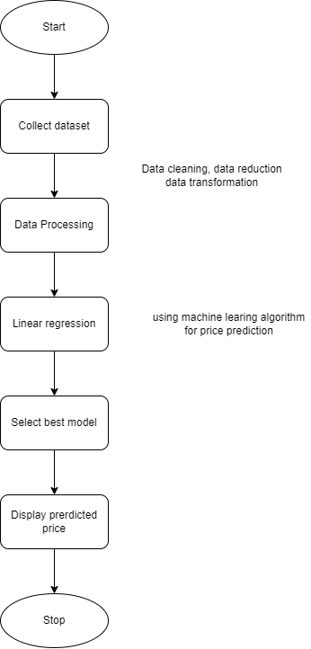

Fig: flow chart for car price prediction

**FUTURE SCOPE**

In future this machine learning model may bind with various website which can provide real time data for price prediction. Also we may add large historical data of car price which can help to improve accuracy of the machine learning model. We can build an android app as user interface for interacting with user. For better performance, we plan to judiciously design deep learning network structures, use adaptive learning rates and train on clusters of data rather than the whole dataset.

**CONCLUSION**

The increased prices of new cars and the financial incapability of the customers to buy them, Used Car sales are on a global increase. Therefore, there is an urgent need for a Used Car Price Prediction system which effectively determines the worthiness of the car using a variety of features. The proposed system will help to determine the accurate price of used car price prediction. This paper compares 3 different algorithms for machine learning : Linear Regression, Decision tree and Random Forest.

**REFERENCES**

1. <https://github.com/rockingshivam5/Intel-Project.git>
2. <https://scikit-learn.org/>
3. <https://machinelearningmastery.com/standardscaler-and-minmaxscaler-transforms-in-python/>
4. <https://stackoverflow.com/questions/29623171/simple-prediction-using-linear-regression-with-python>
5. **<https://www.kaggle.com/goyalshalini93/car-data> (For Dataset).**